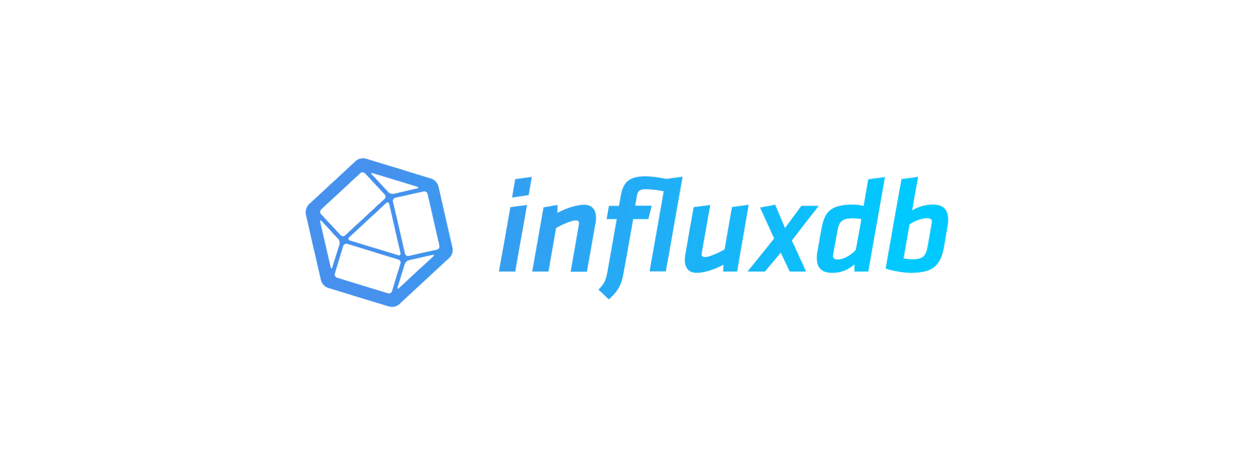

**InfluxDB is an open-source time series database that is designed for handling high volumes of time-stamped data. It is optimized for storing and querying large amounts of data in real-time, making it ideal for monitoring and analytics applications. InfluxDB uses a SQL-like query language called InfluxQL, which allows users to perform complex queries on time-stamped data.**

**Documentation links below:**

**(“**[**https://docs.influxdata.com/influxdb/v2.7/**](https://docs.influxdata.com/influxdb/v2.7/)**”)**

**(“**[**https://www.youtube.com/@influxdata8893**](https://www.youtube.com/@influxdata8893)**”)**

**InfluxDB UI provides several ways to load data from external sources into an InfluxDB instance. Here are some of the ways to load data into InfluxDB using the UI:**

1. **Data Import: The InfluxDB UI provides a data import feature that allows you to upload data from a CSV file or from a URL. To use this feature, click on the "Data" tab on the top of the screen and select "Data Explorer". From there, click on the "Import" button, and follow the prompts to import your data.**

** **



**ADD DATA**

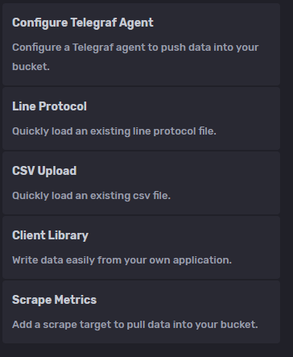

1. **Telegraf: Telegraf is a plugin-driven server agent that can collect and send data from a wide range of sources to InfluxDB. To set up Telegraf, click on the "Data" tab on the top of the screen and select "Telegraf". From there, follow the prompts to configure and start Telegraf. Once it's running, Telegraf will automatically collect and send data to your InfluxDB instance.**
2. **InfluxDB API: You can also load data into InfluxDB using the InfluxDB API. To use the API, click on the "Data" tab on the top of the screen and select "API". From there, you can use the InfluxDB API to write data to InfluxDB. This method requires some programming knowledge to use effectively.**
3. **InfluxDB Line Protocol: InfluxDB supports the Line Protocol format for writing data to the database. You can use the InfluxDB UI to manually enter data in the Line Protocol format. To do this, click on the "Data" tab on the top of the screen and select "Data Explorer". From there, click on the "Write Data" button, and enter your data in the Line Protocol format.**

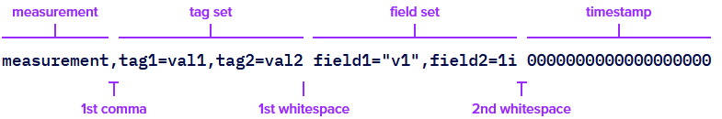

**The line protocol consists of a measurement, tag set, field set, and a timestamp. The measurement is a string that represents the name of the data being stored, while the tag set is a set of key-value pairs that provide metadata about the measurement. The field set is another set of key-value pairs that represents the actual data being stored. Finally, the timestamp is an integer that represents the time at which the data was recorded.**

**Processing data in InfluxDB involves performing transformations, calculations, and aggregations on the raw data stored in the database. Here are some common techniques for processing data in InfluxDB:**

1. **Downsampling: Downsampling involves reducing the granularity of data by aggregating it into larger time intervals. For example, you might want to calculate the average temperature every hour instead of recording the temperature every minute. This can be done using the "GROUP BY time()" clause in an InfluxQL query.**
2. **Continuous queries: Continuous queries (CQs) are pre-defined queries that are automatically executed at regular intervals. CQs can be used to perform complex calculations or aggregations on data and store the results in a separate measurement. For example, you might want to calculate the total energy consumption per day and store the results in a separate measurement.**
3. **Kapacitor: Kapacitor is a data processing engine that can be used to perform advanced processing on data in real-time. Kapacitor supports a wide range of functions such as filtering, transformation, and alerting. For example, you might want to monitor a sensor and trigger an alert if the temperature goes above a certain threshold.**
4. **Data manipulation: InfluxDB also provides a variety of functions for manipulating data, such as mathematical operators, conditional statements, and regular expressions. These functions can be used to transform data or perform calculations on it.**

**To visualize data in InfluxDB using the UI, you can follow these steps:**

1. **Open the InfluxDB UI by going to http://localhost:8086 in your web browser (replace localhost with the IP address of your InfluxDB server if it's running on a remote machine).**
2. **Click on the "Data Explorer" link in the left-hand menu.**



1. **Select the database that contains the data you want to visualize from the drop-down menu at the top of the page.**

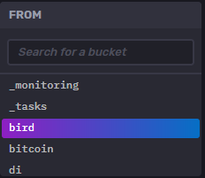

1. **Enter a query in the query editor to retrieve the data you want to visualize. For example, you could enter a query like SELECT * FROM "my_measurement" to retrieve all data from the "my_measurement" measurement.**

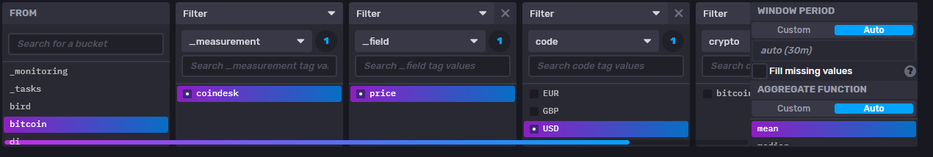

1. **Click the "Submit Query" button to execute the query.**
2. **The results of the query will be displayed in a table below the query editor. To visualize the data, click on the "Visualization" tab at the top of the page.**

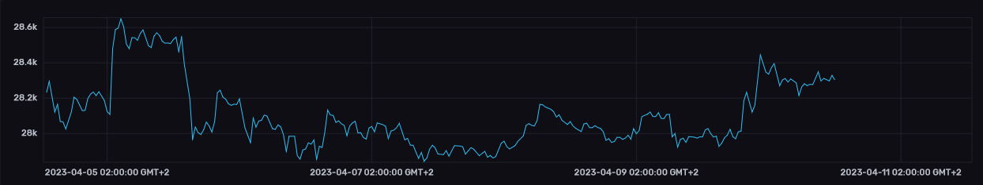

1. **Choose the type of visualization you want to create from the "Type" drop-down menu. There are several visualization types available, including line graphs, bar charts, and scatter plots.**

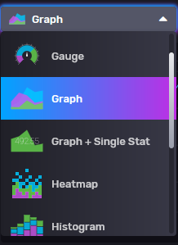

1. **Configure the visualization by selecting the appropriate options in the "Options" tab. For example, you can set the X and Y axes, choose a color palette, and adjust the size of the chart.**

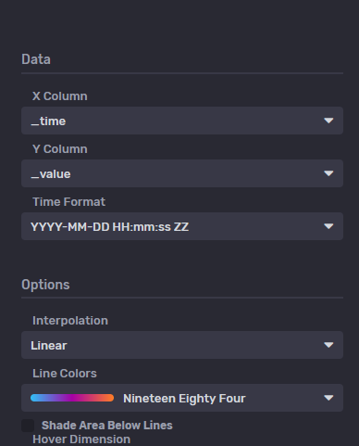

1. **When you're done configuring the visualization, click the "Create" button to create the chart.**
2. **The chart will be displayed on the page, and you can interact with it by hovering over data points or zooming in and out.**

**The Data Explorer in InfluxDB has a query editor that allows users to write SQL-like queries to retrieve data from the database. Users can select the time range for which they want to retrieve the data, and can filter the data based on tags and fields. Once the query is executed, the results are displayed in a table format. The table displays the timestamp, tags, and fields for each data point. Users can sort the data, group the data by tags, and aggregate the data using different functions such as sum, mean, and count.**

**The Visualization tool in InfluxDB allows users to create different types of charts and graphs to represent their data. The tool provides users with several visualization types such as line charts, scatter plots, bar charts, and pie charts. Users can select the visualization type from a drop-down menu, and can configure various options such as X and Y axes, colors, and legends. Once the visualization is created, users can interact with it by hovering over data points, zooming in and out, and toggling data series on and off.**

**The InfluxDB user interface (UI) includes a built-in visualization tool called the "Dashboard Builder", which allows you to create custom dashboards with a variety of visual elements such as line graphs, bar charts, heatmaps, and tables. You can customize your dashboards by selecting data sources, applying filters and aggregations, and defining time ranges.**



**Dashboard variables can be used in several ways, such as filtering data on a visualization or dynamically changing the title or subtitle of a panel based on the selected variable. They can also be used to control the behavior of a dashboard. For example, a variable could be used to control the refresh interval of the dashboard or to toggle between different visualizations.**

**A dashboard variable can be defined as a query or a set of values. When defined as a query, the variable will execute the query and retrieve the results. These results can be used as a list of values for the variable. For example, a query variable could be used to retrieve a list of hosts from a database, and the user could select one or multiple hosts from the list to filter the data on the dashboard.**

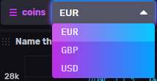

**The dashboard variable here is the currency vs the bitcoin in this example.**

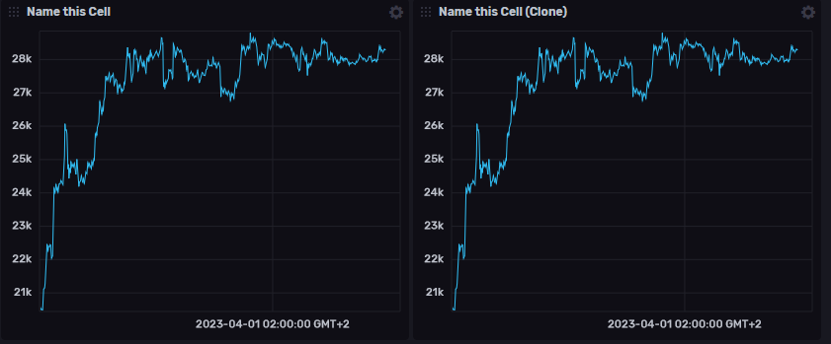

**To use dashboard variables in InfluxDB, follow these steps:**

1. **Create a dashboard: Create a new dashboard or open an existing one in the InfluxDB UI.**
2. **Define a variable: Click on the "Variables" tab on the top of the screen and click on the "New" button. Define the variable by giving it a name and selecting its type (query or set of values).**

 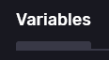 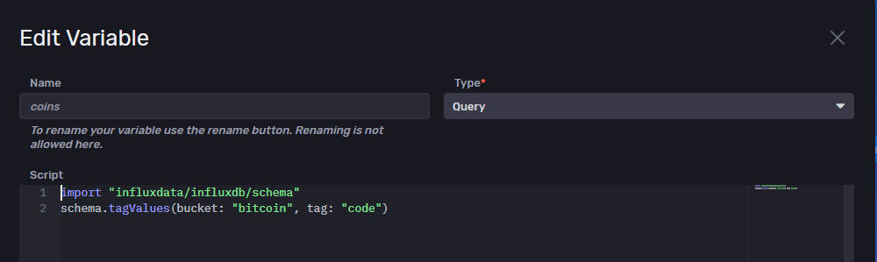

1. **Define the variable query: If the variable is defined as a query, enter the query in the "Query" field. The query should return a list of values that will be used as options for the variable.**
2. **Use the variable in a panel: Select a panel on the dashboard where you want to use the variable. In the panel editor, find the field where you want to use the variable and use the syntax "v.variable_name" to reference the variable. For example, if you want to use the variable to filter data on a line chart, you can use the variable in the WHERE clause of the query.**

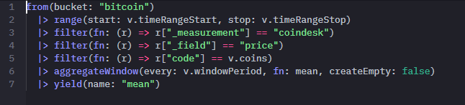

1. **Save the dashboard: Once you have added the variable to your panel, save the dashboard.**
2. **Interact with the variable: Go back to the dashboard and you should see the variable listed on the top of the screen. Click on the variable to open its options and select the value(s) you want to use to filter the data on the dashboard.**

**FAQS**

* **what happens if we imported 2 different csv files with 2 different schemas**
  + if you import a CSV file with schema A, and then later import a CSV file with schema B, both CSV files will be stored in the same bucket. The first CSV file will be stored as a measurement with fields and tags based on schema A, while the second CSV file will be stored as a separate measurement with fields and tags based on schema B.
* **What is a measurement in Line Protocol?** 
  + A measurement in Line Protocol is a string that identifies the data that is being stored. It is similar to a table in a relational database.
* **What are tags in Line Protocol?** 
  + Tags in Line Protocol are key-value pairs that provide metadata about the data being stored. They are used to filter and group data in queries.
* **What are fields in Line Protocol?** 
  + Fields in Line Protocol are the actual data being stored. They are associated with a measurement and can be of different data types, such as integer, float, and string.
* **How do you write a Line Protocol record?**
  + A Line Protocol record consists of a measurement, zero or more tags, zero or more fields, and a timestamp. Here is an example: "measurement,tag1=value1,tag2=value2 field1=1.23,field2=4.56 timestamp".
* **How do you escape special characters in Line Protocol?**
  + To escape a special character in Line Protocol, you need to use a backslash () before the character. For example, to include a comma in a field value, you would write ",".
* **Can you use Line Protocol to write data to InfluxDB?** 
  + Yes, Line Protocol is the format used to write data to InfluxDB. You can use the InfluxDB API or a client library, such as the Python InfluxDB library, to write data in Line Protocol format.